- History & Development
Servant Leader can be defined as a making the highest priority to serve others first
Robert K. Greenleaf, founder of Greenleaf Center for Servant Leadership 1964
Credited the novel The Journey to the East by Herman Hesse in 1956
- Theory of Servant Leadership
According to Robert K. Greenleaf “...The great leader is seem as servant first.”
Group Oriented Approach to Decision-Making to seek out solutions versus the I am the top leader of the group and you do as I say, no questions/comments

III. Characteristics of Leadership² IV. Model of Servant Leadership³
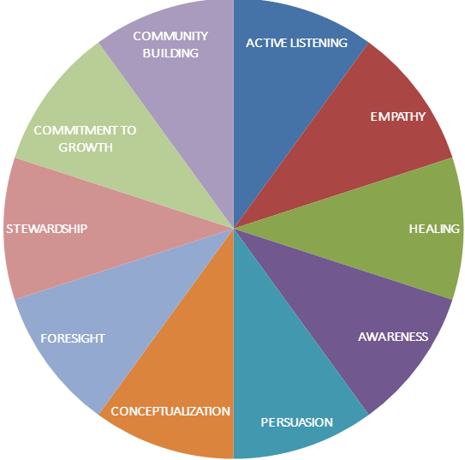
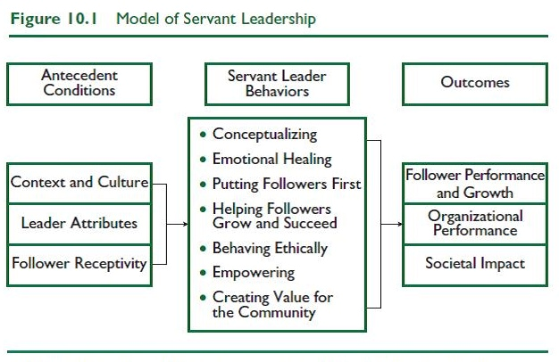

V. Strengths/Weakness/Practical Uses
Strengths | Weaknesses | Practical Uses
Altruism-Caring/unselfish/well-being of others | Name-“Whimsical” contradicts itself | Community Building  Unsung Hero (https://www.youtube.com/watch?v=uaWA2GbcnJU)
Leaders share/shift control | No common definition or theoretical framework | Leadership Education
Not Panacea | Overtone “put others first” confliction with goal setting | Service Learning Programs in Colleges & Universities
SLQuestionnaire-28 items, 7 dimensions(given out in class) | Conceptualization--cognitive ability vs. behavior | Personal Growth-spiritually, intellectually, professionally, emotionally

Greenleaf, R.K. (1991). The servant as leader. Indianapolis, IN: The Robert K. Greenleaf Center. [Originally published in 1970, by Robert K. Greenleaf]. ²https://sites.psu.edu/leadership/wp-content/uploads/sites/8069/2013/03/servant_leadership_model.jpg, Effective Leadership through a Golden Rule Mindset March 27, 2013 by jmj5471 ³https://www.linkedin.com/pulse/servant-leadership-its-application-contemporary-dipti-hattangady-phd, Servant-Leadership & its application in the contemporary organization, Published on August 17, 2015 Dipti SJ Hattangady. PhD, MBA

