Reading and Writing about Statistics
Mr. Manuel F. Negron
New Jersey City University

Gallin & Ognibene (2012) refer to statistical inference as the process through which inferences about a population are made based on certain statistics calculated from a sample of data drawn from that population. This report will compare a popular press article and a scholarly article in terms of the statistical analysis conducted. The first article chosen was published in 2013 by authors Alice Sullivan, Sosthenes Ketende, and Heather Joshi; titled “Social Class and Inequalities in Early Cognitive Scores”. This article provided an empirical assessment of gaps in social classes in early cognitive scores. The article identifies these gaps being attributed to several factors including parenting.
The Atlantic published the second article chosen, “Inequality in Public Schools” by Michael Godsey online on June 15, 2015. This article looks at the disparity, differences in opportunities between “advantaged”, and “disadvantaged” students within public schools.
Mainstream Media

In the article, ““Inequality in Public Schools” (Godsey, 2105) the author highlights several differences between “advantaged”, and “disadvantaged” students within a school as well as public and private schools. These disparities are also reflected throughout the country. Some of the differences between these two groups are struggling students taking remedial classes, while the advantaged students are taking online college courses. The lack of internet accessibility by students at home is another major factor that separates the “advantaged”, and “disadvantaged”.
The author chose to look at differences in SAT scores to compare students in public and private schools. Godsey (2015) mentions that the main private school (which charges about $12,700 annually for tuition) and public school have almost identical average SAT scores: 1830 and 1820 (out of 2400). He also highlights that in the nearby school where he teachers, the differences between honor students and the rest of the student population is almost too large to measure: The seniors taking AP English have an average SAT score of 1890, while those in the regular English classes have an average score of 1590. The authors also identifies that the AP classes do not reflect of the school communities at large. Godsey (2015) states, “In 2013, students in the country who qualified for free or reduced lunch represented nearly half of all high school students but only 27 percent of AP test-takers”.
Based on this article, I could not tell how the statistical analysis was conducted. In this article, the author referred to statistical data from a report published on February 11, 2014 titled, “The 10th Annual AP Report to the Nation”, by the College Board to support the inequality he highlights in his article in terms the number of students who take AP exams versus all high school students. Clearly, the data from this report was collected from the number students who took AP exams by state.
The 10th Annual AP Report to the Nation highlights that when compared to similar peers, research shows that students who score a 3 or higher on an AP exam have higher GPAs in college and perform better in college courses in the discipline than non-AP students who took the introductory class in college. The report also mentions that students who took AP exams graduate college in a shorter period than students who did not take the exam.
While this article was titled, “The Inequality in Public Schools”, I feel that the author referred to too many topics in terms of disparities within a school and between public and private schools. The statistical data referenced in this article in terms of AP exams was just one of the topics mentioned, but the only topic that had data to support it. Therefore, I view this statistical data as weak because it does not support or provide sufficient and specific data to support that author’s purpose, which is to make a claim that there are inequalities in public schools. Students who take AP exams and those who do not are only one of many factors that show inequalities in public schools.

Scholarly Article

In the article, “Social Class and Inequalities in Early Cognitive Scores” (Joshi, Ketende, & Sullivan, 2013) the authors used The Millennium Cohort Study to examine the relationship the relationship between social classes and attainment in the early school years in the United Kingdom. The Millennium Cohort Study answers major questions about the prospects of children born in 2000-2001 in regards to poverty, wealth, quality of family life, and potential outcomes (Joshi, Ketende, & Sullivan, 2013).
This study looks at the social conditions of the child’s first seven years of life to predetermine the potential outcome of the child’s whole life. The sample for this study was selected from all births in a random sample of all sectors disproportionately stratified to include equal representation of poor areas with high concentration of black and Asian families throughout the United Kingdom. The Millennium Cohort Study used the Millennium Cohort survey, which was conducted four times between the ages of nine months to seven years old. Survey one was conducted at nine months, survey two was conducted at age three, survey three was conducted at age five, and survey four was conducted at age seven. During the surveys, interviews were conducted with both parents to collect health and socioeconomic information. The last three surveys also included an assessment of the child’s cognitive development.
Once the data was collected, it was broken down into the following five linear regression models:
- Social Class and Ascribed Characteristics
- Social Class/Ascribed Characteristics and Income/Education
- Social Class/Ascribed Characteristics, Income/Education and Social Resources
- Social Class/Ascribed Characteristics, Income/Education, Social Resources, and Parent Behavior
- Social Class/Ascribed Characteristics, Income/Education, Social Resources, and Parent Behavior, and Child’s Test scores at Age Five
Each model consists of numerous explanatory variables such as the child’s gender, ethnic group, family income, and the age of mother at first birth; just to name a few. The authors in this study used the asterisk rating system of P < 0.05 *, P < 0.01 **, P < 0.001***, with P < 0.05 being statistically significant and P < 0.001 being statistically highly significant, which means that there is less than one in a thousand chance of being wrong. The authors provide a three-page chart seen below with multiple variables with p-values. For this report, I am only going to highlight some of the variables that are considered statistically highly significant.
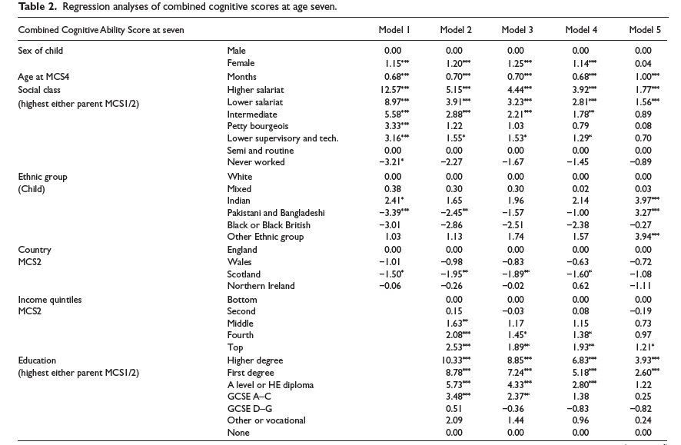
Table 1. Regression analysis of combined cognitive scores at age seven (Joshi, Ketende, & Sullivan, 2013)
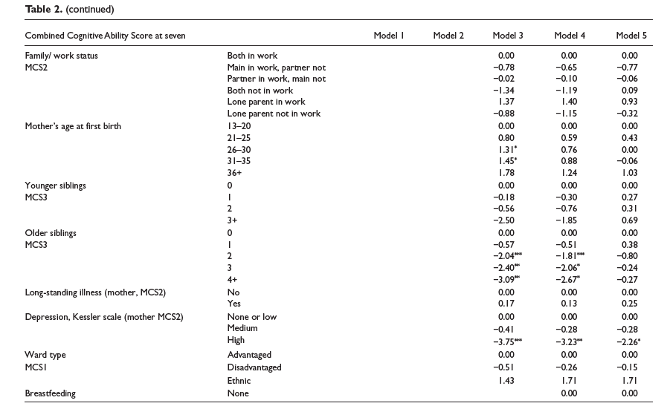
Table 1 continued. Regression analysis of combined cognitive scores at age seven (Joshi, Ketende, & Sullivan, 2013)
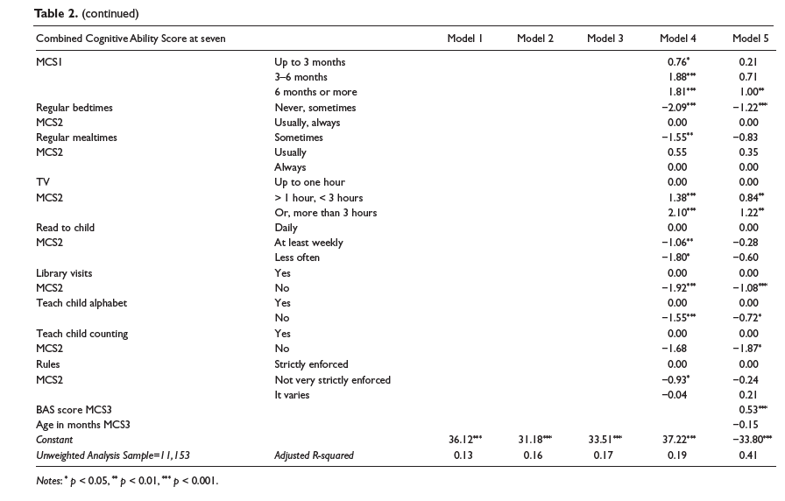
According to linear regression model four and five and the data collected from the surveys, children having regular bed times (never, sometimes) Model 4 is -2.09*** and Model 5 is -1.22***. When looking at library visits by the children Model 4 is –1.92*** and Model 5 is -1.08***. When looking at parents teaching the child the alphabet, Model 4 is -1.55***.
Acording Joshi, Ketende, & Sullivan (2013) this study’s conclusion is that the education of parents and social class is linked to inequalities between the ages of five and seven as well as inequalities in test scores at age seven. The authors’ could not fully explain this by the wide range of measures of parental behaviors and family social resources that were included in the models.
Based on the evidence is this article and the clear data provided, I believe they make a strong point to say that education of parents and social class is linked to inequalities between the ages of five and seven. This longitudinal study started collecting data on children through surveys at the age of nine months and up to the age of seven. The sample for this study was selected from all births in a random sample of all sectors disproportionately stratified and the surveys were conducted at four points in the child’s life to include assessments of the child’s cognitive development during the last three surveys. The authors’ also used the asterisk rating system of P < 0.05 *, P < 0.01 **, P < 0.001*** to identify multiple variables that were statistically and statistically highly significant. Several of the variables explanatory variables were identified as has having a P value greater than 0.001, clearly means that there is less than one in a thousand chance of being that variable being wrong.

Conclusion
When looking at the two articles that I chose for this report, I agree that the article titled, “Social Class and Inequalities in Early Cognitive Scores” clearly provided much more information than the article titled, “Inequality in Public Schools”. The social class article introduced the problem in the beginning of the article and was followed by the purpose of the study, the details of how the study was going to be conducted, how the samples were going to be identified, and how the data was going to collected and analyzed. Once the data was collected, it was broken down into five linear regression models with explanatory variables and each variable was given a P value.
The “inequality” in schools article started with a scenario and statement on how inequality exists within a public school and between public and private schools. The author continued to provide examples and real world personal experiences on inequalities that he has experienced or encountered, but does not provide statistically significant data to support his claim that there is “Inequality in Public Schools”. The authors identifies wide ranges of examples, which can make the reader feel as if he was venting. Despite providing so many examples of inequality in schools, he only referenced a report on the numbers of students who take AP exams by states and compared that number to the number of actual high school students.
If I were the author of this article of would have focused on one specific factor that I felt was an inequality in public schools and built my study and research around that specific factor. The goal of my research is to collect as much data with variables of P values ranging from < 0.05 *, P < 0.01 **, P < 0.001*** to support my claim and ultimately answer my research questions.
I feel that the Millennium Cohort Study was too long of a study and I wondered on how they kept track of the participants if they moved or if families got divorced or separated.

References
Gallin, J. I., Ognibene, F. P., & Johnson, L. L. (2018). Principles and practice of clinical research. London: Elsevier/Academic Press. doi:https://doi.org/10.1016/B978-0-12-382167-6.00021-7
Godsey, M. (2015, June 16). How Public Schools Reinforce Inequality. Retrieved March 17, 2018, from https://www.theatlantic.com/education/archive/2015/06/inequality-public-schools/395876/
Salkind, N. J. (2007). Statistics: For People Who (Think They) Hate Statistics (6th ed.). Thousand Oaks, CA: SAGE Publications.
Sullivan, A., Ketende, S., & Joshi, H. (2013). Social Class and Inequalities in Early Cognitive Scores. Sociology, 47(6), 1187-1206. doi:10.1177/0038038512461861
The 10th Annual AP Report to the Nation (Publication). (n.d.). College Board.

Appendix A
Scholarly Article
Link to Article
Social Class and Inequalities in Early Cognitive Scores
Sullivan, A., Ketende, S., & Joshi, H. (2013). Social Class and Inequalities in Early Cognitive Scores. Sociology, 47(6), 1187-1206. doi:10.1177/0038038512461861

Appendix B
Mainstream Media Article
Link to Article
The Inequality in Public Schools
Godsey, M. (2015, June 16). How Public Schools Reinforce Inequality. Retrieved March 17, 2018, from https://www.theatlantic.com/education/archive/2015/06/inequality-public-schools/395876/

