White Paper: Principal Impact on the Student Achievement Gap
Mr. Manuel F. Negron
New Jersey City University

Introduction
Effective education leadership impacts improvement in teaching and learning. For decades’ educational systems have gone through school reform efforts and what has been proven is that leadership matters. Effective leadership promotes the learning of all children, which results in overall academic success. Leadership not only matters: it is second only to teaching among school-related factors in its impact on student learning. The impact of leadership tends to be greatest in schools where the learning needs of students are the highest priority.
Problem
The term "achievement gap" refers to the differences between the test scores of minority and/or low-income students and the test scores of their White and Asian peers. Achievement gaps in test scores affect many different groups. Disparities between the scores of students with different backgrounds are evident on large-scale standardized tests. Test score gaps often lead to longer-term gaps, including high school and college completion and the kinds of jobs students secure as adults.
Every couple of years a random sample of students between the ages of 9 - 17 year-olds from around the United States are given tests in math and reading as part of the National Assessment of Educational Progress (NAEP). NAEP is referred to as "The Nation’s Report Card”. It is designed to provide the public with an objective assessment of the math and reading skills of American children. NAEP has used the same tests since the 1970s and therefore can use it to compare the reading and math skills of children today with those of their parents’ generation. NAEP can also be used to examine trends in the White-Black and White-Hispanic achievement gaps. These trends are illustrated in figure 1 below.
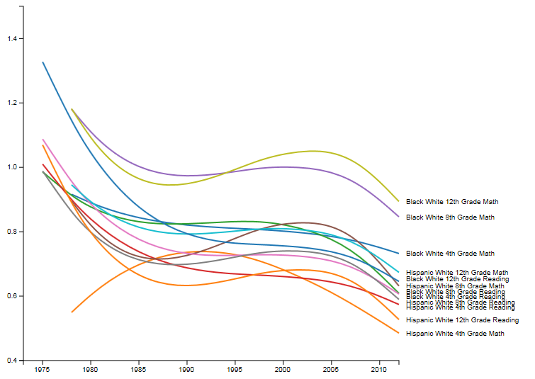Figure 1. Achievement Gap in Standard Deviation, reprinted from Stanford Center for Education Policy Analysis, by The Educational Opportunity Monitoring Project.

White-Black and White-Hispanic achievement gaps have decreased since the 1970s in all grades and in reading and math. The gaps decreased in the 1970s and the first half of the 1980s, but then progress remained flat. Achievement gaps increased in the late 1980s and the 1990s. Since the 1990s, achievement gaps in every grade and subject have been declining. As of 2012, the White-Black and White-Hispanic achievement gaps were 30-40% smaller than they were in the 1970s. However, the gaps are still very large, ranging from 0.5 to 0.9 standard deviations. (Retrieved from http://cepa.stanford.edu/educational-opportunity-monitoring-project/achievement-gaps/race/, 2017).
As there remains to be great disparities in achievement gaps, the goal of school reform efforts is to improve teaching and learning. There are major differences in how they approach reform, but the foundation of the success of reform lies the motivations and capacities of school leadership. The chance of any reform improving student learning is meaningless unless leaders understand its purpose and what is required to make it work. Effective leadership is crucial in order to close the achievement gap and turn around low performing schools. While there are several different styles of leadership; all styles must have three best practices needed to achieve effective leadership. An effective leader must implement the following three best practices:
- Set directions – set a clear plan that everyone understands, establish high expectations/standards, and use data to monitor and analyze progress and performance.
- Develop people – provide teachers and staff with the support and training to needed succeed.
- Make the organization work - ensure that the range of incentives in schools fully support teaching and learning.
While there are many essentials to the quality effective leadership, leaders must be trained on the key aspects of becoming turn around school leaders. Educational systems cannot continue to throw good leaders into bad systems without the proper training, mentoring, and support. Even the best leaders will burn out without the proper support.

Solution

References
Racial and Ethnic Achievement Gaps. (n.d.). Retrieved November 19, 2017, from http://cepa.stanford.edu/educational-opportunity-monitoring-project/achievement-gaps/race/

