Operation Escape to the Rescue
Manuel F. Negron
New Jersey City University

Throughout the United States, escape rooms are becoming increasingly popular with families, friends, and coworkers. Escape rooms are games were groups of participants engage in a themed room to find clues, solve puzzles, and crack codes, to meet the objective within a specific time and ultimately “escape”. Escape rooms are attractive to people looking for a non-traditional game in which participants must have a specific set of skills and knowledge to play. Escape rooms also incorporate exercises to strengthen team building. Many educational institutions are also attracting to escape rooms because they encourage players to engage in creative and critical thinking. In an interview with Scott Nicholson, a professor of game design and development at Wilfrid Laurier University, he informed Zara Stone, reporter for The Atlantic magazine, “Escape rooms create a moment of passion around specific topics that then can be used as the spark to then ignite interest in something for a player to learn more about later” (Stone, 2016).
Strickland and Kaylor (2016) suggest that when participants take part in a game based learning experience; it enhances learning and interest through the active learning environment. It also allows students to take control over their environment by incorporating teamwork, critical thinking, prior knowledge, time management, and creativity. Participants are able to identify their strengths and weaknesses, increase their motivation for learning, and receive real-time feedback to enhance their knowledge through gaming simulation (Mawhirter & Garofalo, 2016).
Informal learning environments such as escape rooms provide students with valuable motivational opportunities to learn. These environments can have an impact on learning while addressing critical skills needed in education that might be missing in formal learning environments (Sasson, 2014).

Design Principles
Considerations taken in the design of this escape room are Don Norman’s (2013) concept of affordances, which are viewed as interactions between people, animals, and/or machines and their surroundings. The interactions will be used to determine the capabilities of how the escape room will be used. Understanding affordances is crucial to designers because they have to understand the relationship and its impact on the environment before they can design the product. The goal is to identify how effective participants will relate/interact with the escape room theme and the activities presented.
Universal Design for Learning (UDL) will also be considered in designing the critical thinking activities, puzzles, problems to help address learner variability by recommending flexible goals, methods, materials, and assessments to meet these varied needs of participants.
Case Study/Mission Overview
There has been a recent trend of kidnapping Soldiers by local militia in a small town in Kentucky. After an ARMY basic combat training graduation ceremony, groups of Soldiers were given a weekend pass to celebrate in town. Late Saturday night a group of soldiers were kidnapped and taken to an abandoned ammunition warehouse. One of the soldiers who was previously kidnapped, but escaped knew that the militia would eventually bring other Soldiers to the warehouse. He wanted to help them escape before they were killed; he left some clues that will help the Soldiers to escape, but participants need to think and act fast in order to save their lives. The have 60 minutes to rescue the Soldiers and use the trucks provided at the end to escape.

Educational Objective/Relevance
The educational objective of this escape room is to inspire and engage players of ages 16 and older by incorporating key content knowledge skills needed for academic success such as problem-solving, creativity, teamwork, engagement, goal-minded, and improving the ability of focus.
The relevance of this room is to provide people, especially military veterans with a sense of belonging and comradery towards and overall goal, to complete the mission and rescue the kidnapped Soldiers. Many people in society suffer from the invisible signs of anxiety and depression. This escape room will support the social/emotional needs of participants by providing them with the opportunities to engage collaboratively with teammates and focus on the assigned task.
Description
All participants will wear military uniforms during their experience and will be assigned specific roles and titles. The room is located in an old abandoned ammunition warehouse, which truly feels dark and eerie. Upon entering the warehouse, the main doors slam shut and the mission begins. The key is to effectively communicate with your teammates, find clues, and solve the puzzles and survive to get to the next room and eventually escape with the kidnapped Soldiers. As you move from room to room, the scenarios become more challenging and the activities/puzzles require critical thinking as a team.
Feasibility
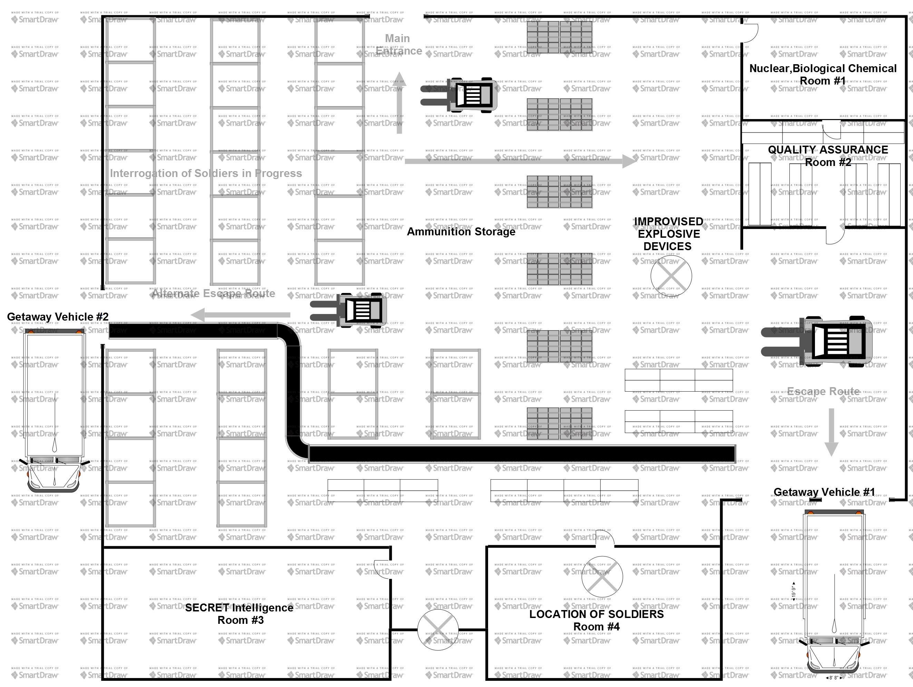
A feasibility assessment will be conducted to determine the strengths and weaknesses of the proposed escape room design in the anticipated environment (the warehouse) and the resources needed to proceed with the design and for overall success. The main goal of the assessment will be to measure the cost against the expected benefits. The anticipated escape room design will be feasible because the warehouse rental fee will be $2500 a month to include all fixtures and furnishings currently in the warehouse. This benefit will save excessive spending on props. The warehouse will need basic cosmetic renovations, as the plan is to have the most authentic warehouse environment possible. The cost of participating in the escape room is $25.00 per person with groups as large as 10. The most common participants are groups of four, which allows for $800 revenue daily at minimum. The venue will be open seven days a week and there will be eight hourly time slots to be reserved to participate.
Figure 1. Operation rescue escape floor plan
REFERENCES
Adams, V., Burger, S., Crawford, K. & Setter, R. (2018). Can You Escape? Creating an Escape Room to Facilitate Active Learning. Journal for Nurses in Professional Development, 34, E1–E5. 10.1097/NND.0000000000000433.
Allen, S., & Gutwill, J. (2004). Designing Science Museum Exhibits with Multiple Interactive Features: Five Common Pitfalls. The Museum Journal, 47(2), 199-212.
CAST. (2011). [available online] Universal Design for Learning guidelines, Version 2. Retrieved March 15 2011 from http://www.udlcenter.org/sites/udlcenter.org/files/UDL_Guidelines_Version_2.0_(Final).doc
Hofstrand, D., & Holz-Clause, M. (n.d.). What is a Feasibility Study? | Ag Decision Maker. Retrieved July 29, 2018, from https://www.extension.iastate.edu/agdm/wholefarm/html/c5-65.html
Mawhirter, D., & Garofalo, P. (2016). Expect the unexpected: Simulation games as a teaching strategy. Clinical Simulation in Nursing, 12 (4), 132. doi:10.1016/j.ecns.2015.12.009
Norman, D. A. (1988). The psychology of everyday things. New York: Basic Books.
Norman, D. A. (2013). The design of everyday things: Revised and expanded edition. New York: Doubleday.
Sasson, I. (2014). The Role of Informal Science Centers in Science Education: Attitudes, Skills, and Self-efficacy. Journal of Technology and Science Education, 4, 3rd ser., 167-189. Retrieved July 30, 2017, from http://dx.doi.org/10.3926/jotse.123.
Stone, Z. (2016, July 28). Why Teachers Are Asking Students to Escape From the Classroom. Retrieved July 11, 2018, from https://www.theatlantic.com/education/archive/2016/07/the-rise-of-educational-escape-rooms/493316
Strickland, H. P., & Kaylor, S. K. (2016). Bringing your A-game: Educational gaming for student success. Nursing Education Today,40, 101Y103. doi:10.1016/jnedt

